Month 2: Week_1 Report
• In-depth Snort rule syntax
• Write at least 2 custom detection rules
• Integrate custom rules into configuration
- In-Depth Snort Rule Syntax
Introduction: Snort is an open-source Network Intrusion Detection System that monitors network traffic and detects malicious activity. In Week 1, the objective was to study Snort rule syntax, create custom detection rules, and integrate these rules into the Snort configuration.
Snort Rule Syntax
Rule Header:
- action (alert, log, pass)
- protocol (TCP/UDP/ICMP)
- source IP, source port
- direction operator (→)
- destination IP, destination port
Rule Options:
- msg
- content
- nocase
- sid
- rev
- flags
- threshold
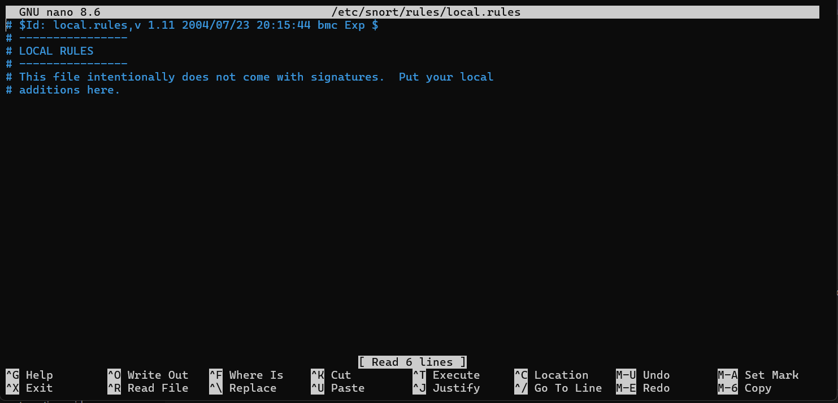

Two Custom Rules
Custom Rule 1: Suspicious User-Agent Detection
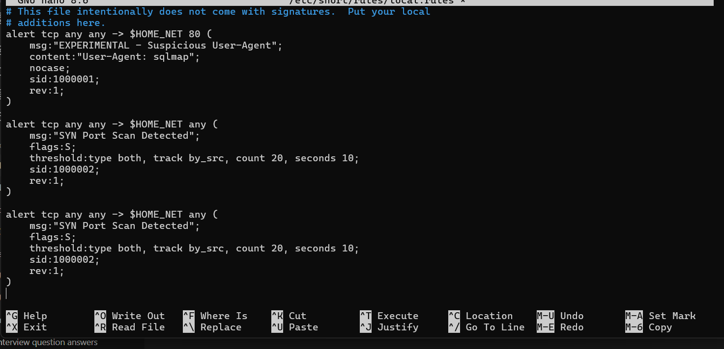

Write explanation:
- This rule checks HTTP traffic
- Detects SQLMap scanner
- Uses content matching
- Alerts whenever User-Agent contains “sqlmap”
Custom Rule 2: SYN Port Scan Detection
Explanation:
- Detects repeated SYN packets
- Indicates port scanning
- Triggered if 20 SYN packets appear within 10 seconds
- Helps catch Nmap scans
Integrating Custom Rules
- Rules were added into local.rules
- Snort automatically loads this file
- How the file was edited using
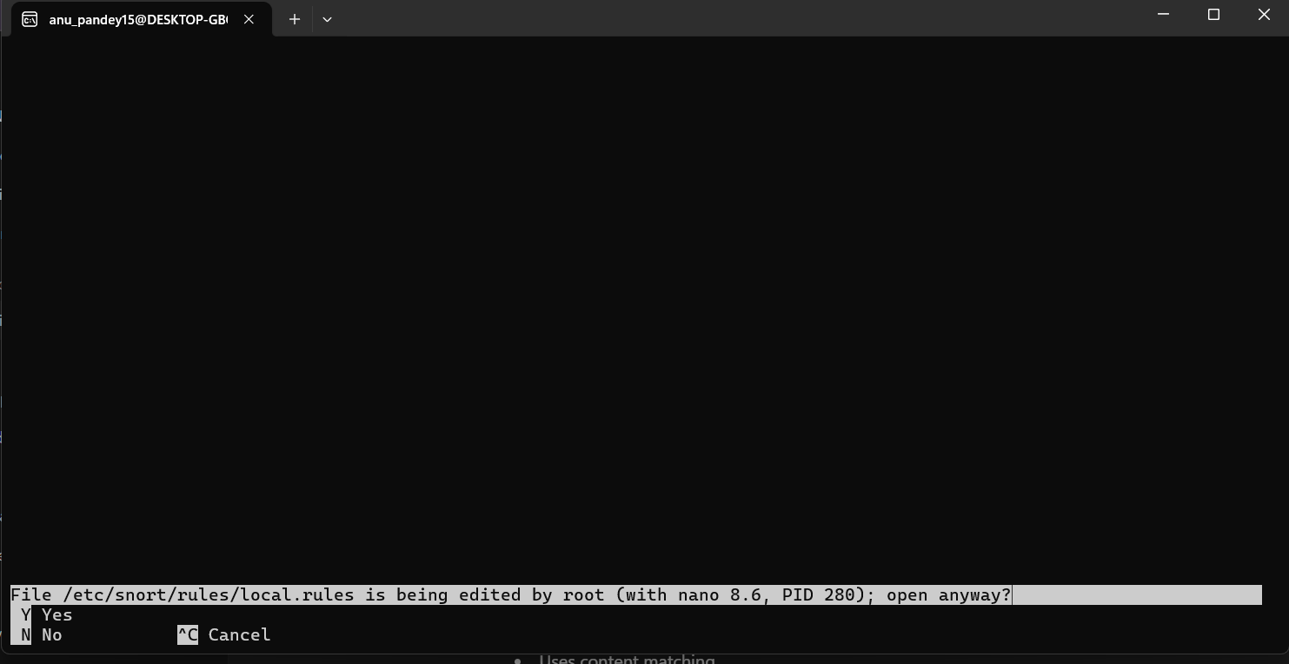

Running Snort
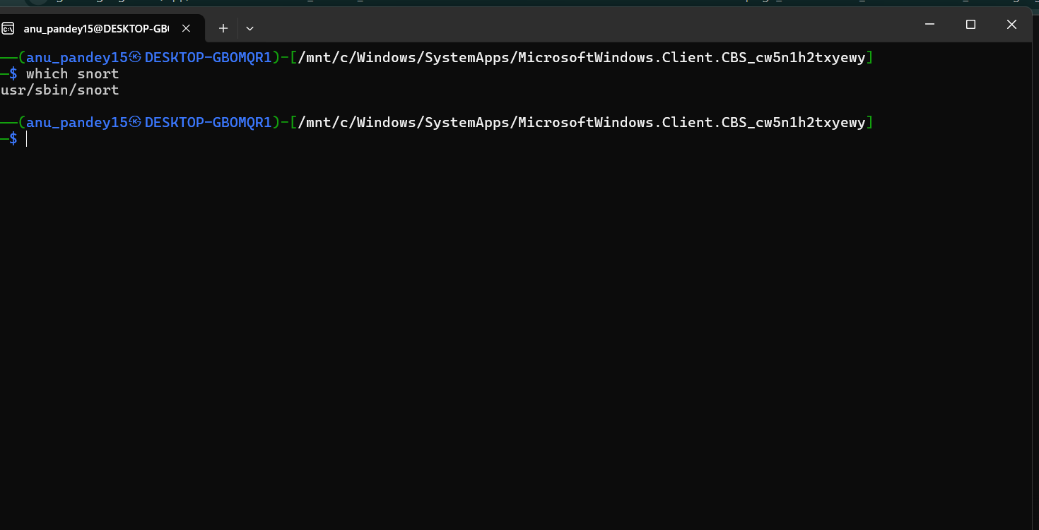

1. Snort enters live monitoring mode
- What this means: Snort has successfully initialized. It has loaded its main configuration file (snort.conf), identified the network interface it will watch (e.g., eth0), and loaded all the necessary rule sets, including your custom rules.
- Action: The Snort process begins running in the background (or foreground, depending on the flags), dedicating its resources to analyzing network traffic in real-time. It is now actively listening and waiting for data to pass through the selected network interface.
2. It listens for packets
- Action: Snort operates as a sophisticated packet sniffer. It places the specified network interface (like eth0) into promiscuous mode. This allows it to see and copy every single packet traveling across that network segment, regardless of whether the packet is addressed to the machine running Snort.
- Process: As packets arrive, they are passed through Snort's various inspection engines:
  - Preprocessors: These prepare the data (e.g., reassemble fragmented packets or decode HTTP requests) for detailed analysis.
  - Detection Engine: This is the core part where the content of the packet is checked against the thousands of rules it has loaded.
3. Custom rules will trigger alerts when conditions match
- Action: The detection engine systematically compares the packet's headers and payload (the data) against all the rules in the rule set.
- Trigger Mechanism: When a packet's characteristics perfectly match all the criteria defined in a rule, that rule is said to trigger.
  - Example (Your Rule): If an incoming packet is TCP, destined for port 80, and contains the string "User-Agent: sqlmap", it matches your custom rule (sid:1000001).
- Result: The action specified in the rule is executed. In the case of an alert action (like in your rule), Snort generates a notification, often logging it to a file or sending it directly to the console (because of the -A console flag) to notify an administrator of a potential threat.
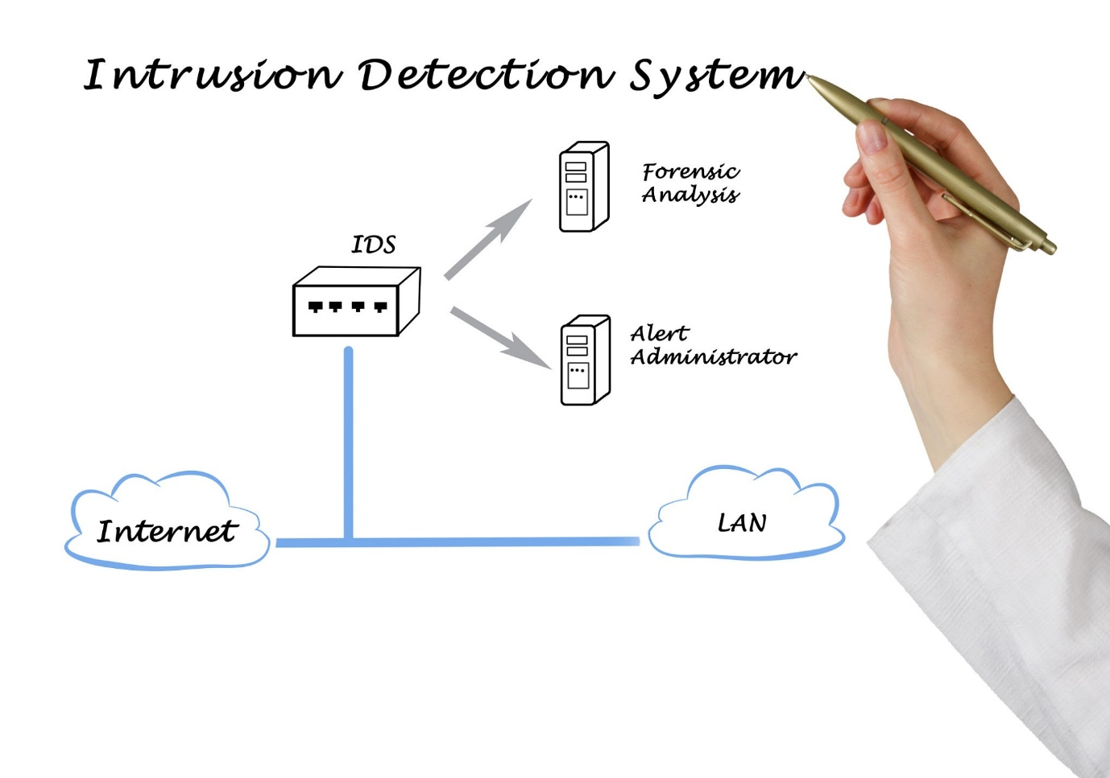
Explore
In summary, Snort is constantly watching, and your custom rule gives it the intelligence to instantly recognize and flag a specific, known attack tool (sqlmap) as soon as its traffic hits your network.

